Java program

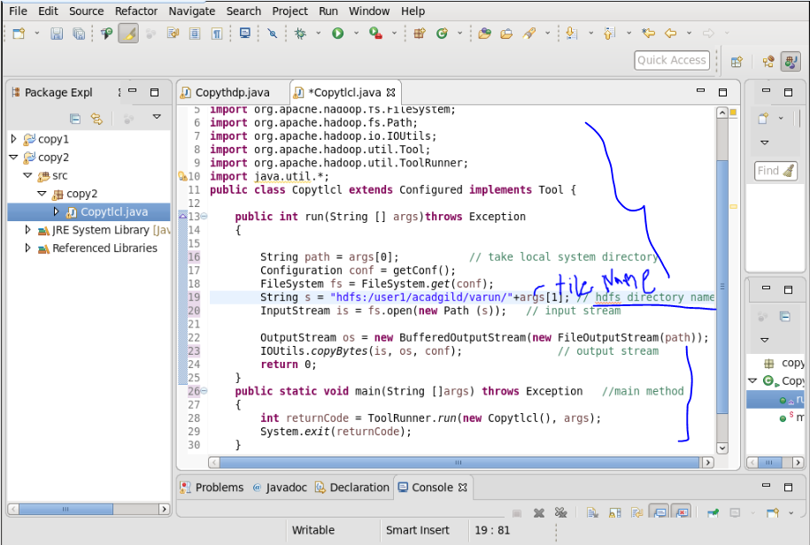

Output:

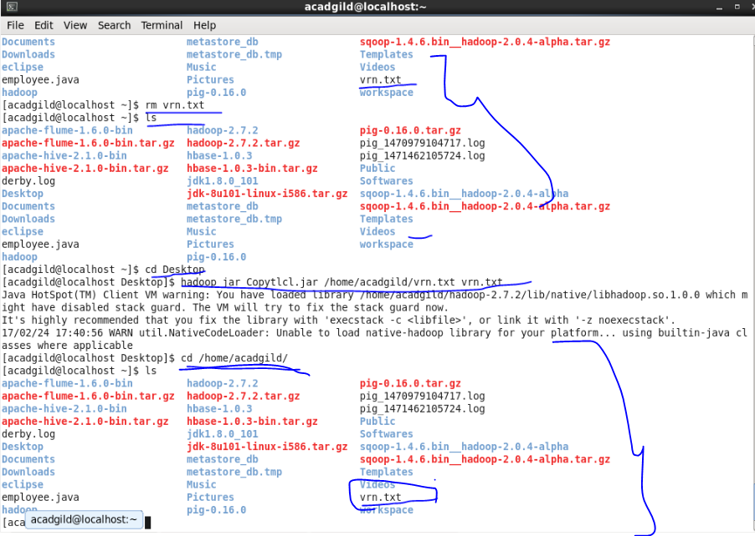

Q2..

DFSInputStream:

It Handles communication of the namenodewith various datanode and also Handles integrity of data contained by the blocks. DFSInputStream Manages data read activity in case of datanodefailure and it is calledCalled internally by FSDataInputStream.

**FSDataInputStream :**

It Provides stream (channel) for reading data and FSDataInputStream Lets the application read from a file.

FSDataInputStreamin = null;

in = fs.open(new Path(uri));

**FSDataOutputStream :**

Provides stream (channel) for writing data

Codes are given below:

OutputStreamout = fs.create(new Path(dst));

IOUtils.copyBytes(in, out, 4096, true);

**DFSOutputStream :**

Handles communication of the namenode with various datanodes and Called internally by FSDataOutputStream.